Animal & Welfare
Research Group

Horse collection centres +
slaughterhouses

Report on site visits in Argentina and Uruguay

Bert Driessen
Jos Van Thielen

December 2019
Table of contents
Preface 3
Programme 4
Summary and conclusion 5
Photographic material 8

Preface

This report reflects the findings (visual observations and measurements of environmental parameters) at the time of the follow-up company visits, which lasted a few hours per company. The situation (animals, staff and infrastructure) was studied at the time of the visit and the observations made were then tested against standards, norms, etc. relating to animal welfare. In addition, photographic and video material was gathered during the site visits in order to be analysed afterwards.
During the 10-day tour of Argentina and Uruguay, four slaughterhouses and three collection centres were visited. A meeting was also held with representatives of the slaughterhouses (Lamar, Solemar, Land, Sarel, Infriba)
The site visit was conducted by Bert Driessen and Jos Van Thielen of the Animal & Welfare research group, who have many years’ experience in the field of animal welfare and behaviour, and more specifically in relation to the monitoring of animals during their transport to and stay at slaughterhouses.

Programme
The travel plan started in Argentina with a visit to the Lamar slaughterhouse and a meeting with representatives of the Lamar-Land L-Solemar-Sarel slaughterhouses. The group then moved on to Uruguay, with visits to the Sarel and Clay slaughterhouses, which together account for 90% of horse slaughtering in Uruguay. Two collection points/centres for horses were also visited in Uruguay. This was followed by visits to one additional slaughterhouse (Land) and a collection centre in Argentina.
Saturday, 2 November 2019
Visit to/audit of Lamar slaughterhouse (Argentina)
Meeting with representative of the Solemar slaughterhouse
Meeting with representatives of the Lamar, Land L, Solemar and Sarel slaughterhouses.
Monday, 4 November 2019
Visit to/audit of Sarel slaughterhouse (Canelones Zabala Department, Uruguay)
Visit to/audit of horse collection centre at the Sarel slaughterhouse site (Uruguay)
Tuesday, 5 November 2019
Visit to/audit of Clay slaughterhouse (Uruguay)
Visit to/audit of horse collection centre at the Clay slaughterhouse site (Uruguay)
Wednesday, 6 November 2019
Meeting with representative of the Infriba slaughterhouse (Argentina)
Thursday, 7 November 2019
Visit to/auditor of the Land L slaughterhouse (Argentina)
Visit to/audit of the horse collection centre at the site of the Land L slaughterhouse (Argentina)
Friday, 8 November 2019
Meeting with Senasa (Argentina)

Summary and conclusion
During the first 10 days of November 2019, two researchers from the Animal&Welfare research group visited two slaughterhouses in Uruguay, namely, the Sarel and the Clay slaughterhouses, which together account for 90% of horse slaughtering in Uruguay. The same two researchers also visited two Argentinian slaughterhouses (Land L and Lamar). The two researchers are experts in the field of animal welfare at agricultural businesses, during transport and at the slaughterhouse. At each company visited, the company executives and staff collaborated fully and granted access to all their premises. At the request of the research team, the horse driving, stunning and bleeding procedures were demonstrated at each operational company, so as to be able to form a good overview of the expertise and infrastructure available.
Systematic testing of the infrastructure in place (based on the Five Freedoms) in terms of animal welfare was conducted. The facilities for unloading the animals, driving them to temporary waiting areas, the facilities for driving them to the stunning area and the facilities in this area were systematically inspected. The existing infrastructure was subjected to visual inspection so as to be able answer a number of questions. Is all the necessary infrastructure present to enable animal-friendly treatment of the horses? The floor staff were observed for several hours in order to assess their skills and expertise in handling horses (in what are not natural circumstances for the animals) and to answer the following questions. Did the staff have sufficient skills to handle the horses in a speedy and animal-friendly manner? Is the staff able, sufficiently aware and experienced to accurately estimate potential problem situations and handle them correctly? During the site visits, objectively measurable and appropriate parameters regarding animal welfare such as light intensity, temperature, air flow, ambient noise, disturbing shafts of light and shadow spots were systematically recorded at various spots at the companies.
On the first evening, a meeting took place between the auditors/researchers of the Animal&Welfare group and the participating companies in South America. This was attended by delegations from Solemar, Lamar, Pico/Land L and Sarel. The two auditors presented their findings from the past few years to the group.
A number of critical points were mentioned which require attention.
During the years when they made their observations, the researchers/auditors noted various adaptations and improvements in both the infrastructure and the handling of the animals (and the human-animal interaction).
We would like to draw attention to four very specific points here: (1) suitability for transport, (2) trailer characteristics, (3) welfare-friendly and proper handling of the animals, (4) the environment.
(1) Suitability for transport
During our visits, we noticed animals in the waiting area of the slaughterhouse that were not suitable for transport: lame animal, wounded animal, etc. Animals that are not fit for transport may not be placed on means of transport. In Europe there is a document entitled “Practical Guidelines to Assess Fitness for Transport of Equidae (Horses, Ponies, Donkeys and their Hybrids)”. This document can be used as a guide to determine whether a horse is fit for transport or not.
Another important point in need of attention is the presence of foals in the waiting area and enclosures on the slaughterhouse site.
A few suggestions relating to the issue of horses being ‘fit for transport’. We advise checking all horses systematically when the trailer is unloaded. When a horse is noticed during unloading in the slaughterhouse that is not fit for transport, it should be removed from the group and slaughtered immediately (emergency stunning on the truck or at the unloading quay if necessary). The findings from every incoming trailer carrying horses should also be recorded. The carriers and suppliers should also be informed of these findings.
(2) Characteristics of the truck
Appropriate attention should be paid to the floor of the truck, the height of the trailer and above all the height of the gate and the density of the animals on the trailer. Attention should also be paid to the way the animals are handled as they are unloaded and driven.
(3) Handling the horses
The truck or horse driver should understand the signals sent out by the animals during unloading and driving and adapt his actions accordingly. Aids should also be used properly. The driver needs to assess the effect of his actions on the animals, not only on the horse on which he is focused, but also the horses in the surrounding area, who also pick up the signals form the driver and may be stressed by these.
Moreover, it is important that any adaptations and maintenance work on the infrastructure should if possible not be carried out in the presence of the animals.
The horses must be showered before slaughtering. The way this is done can have a great impact on the stress level of the horses that undergo these showers. Do not use a typical water pressure to spray the horses. We advise installing a shower that automatically starts up with low pressure and produces a very fine spray.
It is essential that the driver handles the animals calmly at all times. Do not use an electric prod to help drive the animals. Do not hit the horses with a stick or the hand.
(4) The environment
The presence of shelter against any adverse weather conditions or to provide shade (for example, by providing trees in the horse collection centre) is important. In particular, care should be taken to prevent mud and ensure a permeable floor to drain surplus water quickly. The availability of pure drinking water and possibly fodder is also important.
The representatives of the slaughterhouses (Solemar and Infriba) which were examined in 2018 and for which no follow-up visit was planned during this 10-day tour came to the meetings in Buenos Aires themselves to explain the adaptations made or to be made in the near future (both to infrastructure and in the way the horses are handled).
The research team was able to observe that at all the companies they had visited on a previous occasion (Lamar, Sarel, Clay and Land L), many recommendations of the earlier site visits have been taken to heart and the points needing improvement have been addressed. For instance, last year mention was made of the problem of heavy rainfall which can lead to a soggy/muddy floor in uncovered waiting areas. Spacious facilities in covered waiting areas are now available in various slaughterhouses (Figure 1, Figure 2, Figure 3 and Figure 4).
Another improvement that attracted attention was the stress experienced by the horses during showering. It was suggested that showering could be made less stressful by starting gradually with a very fine spray, increasing the intensity of the water over time. The Sarel slaughterhouse took up this suggestion; during our visit this year, we noted that they have installed an automatic shower in the last section of the driving passageway in front of the restraint box, so that the horses no longer become anxious when the shower starts (Figure 5). This is an example for others.
This year, we were also able to observe the new Clay slaughterhouse now that it is fully operational. Both the waiting stall and the driving path to the restraint box have been built in line with the Temple Grandin animal welfare friendly principles: a fishbone-shaped waiting stall, high, equally close side walls in the driving passages, no right angles in the driving passage and a winding but ascending passage to the restraint box. This makes driving the animals from the waiting areas to the stunning area far calmer, better for animal welfare but also, and above all, far more efficient (Figure 6, Figure 7 and Figure 8).
However, during our visits in November 2019, a few additional points needing improvement were identified in order to promote handling of the animals that is efficient and better for animal welfare (e.g. driving the animals) and thereby reduce stress for the animals. The most important factor here is still the need to reduce disruptive noises in the slaughterhouse. High-pitched noises caused by metal on metal or metal on concrete are the main culprits here.
On the last day of the team’s stay in South America, a symposium was organised at Senasa. The researchers gave a presentation about the finding of the past few years. This presentation was then debated and a number of practical aspects were discussed. For instance, it was reported that there is no obligation to shower horses in Argentina, but showering is best to prevent dust getting in when the cut is made in the abdomen of the carcass. Showering the abdomen and legs of the horses is sufficient for this. It was also pointed out that all horses that come to the slaughterhouse must have an electronic ear tag. The SENASA representatives also said they are prepared to delegate a staff member in Europe for any discussions (on Argentinian horses).
As a general conclusion, we can state that in the light of the visits over the past four years and of the on-site observations, there is definitely a positive development in Argentina and Uruguay in the area of animal welfare during the collection, transport and slaughter of horses. We have noted increasing involvement and understanding on the part of everyone involved: slaughterhouses, collection centres, supervisory body (Senasa) and universities.

Druk <Ctrl + Alt + Shift + S> om het taakvenster met stijlen weer te geven

Photographic material
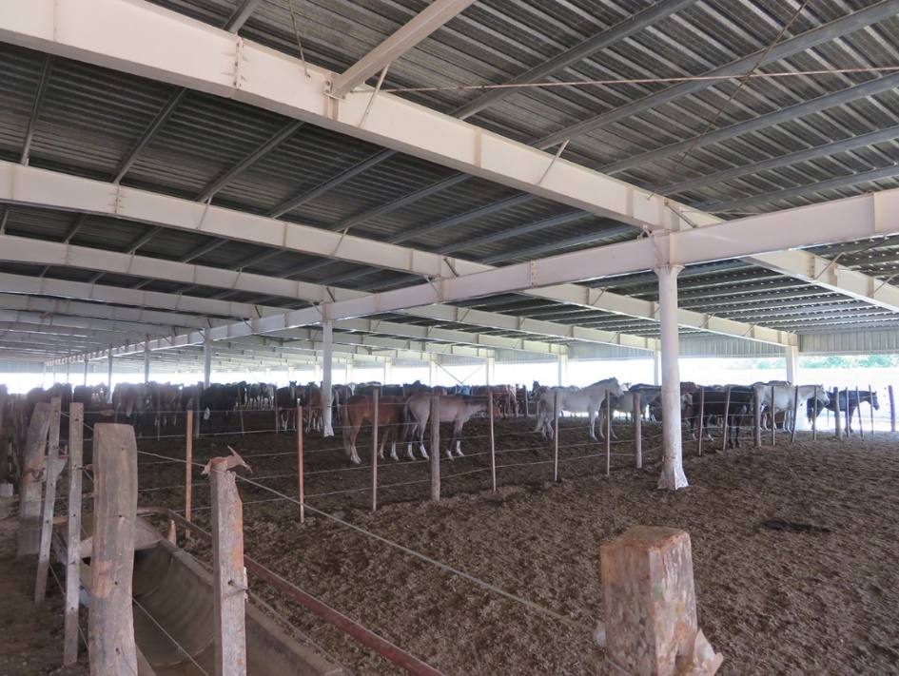
Figure 1: Spacious covered waiting area (Lamar) with facilities for water and fodder.
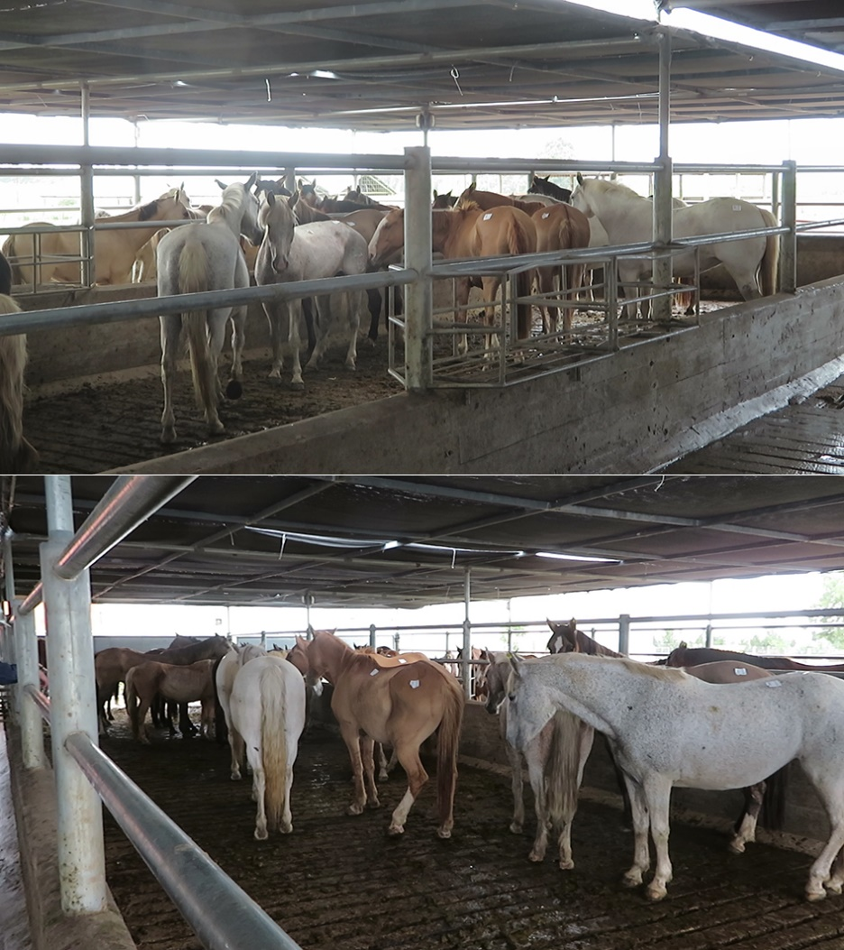
Figure 2: The horses stand quietly in the covered waiting area in Sarel.
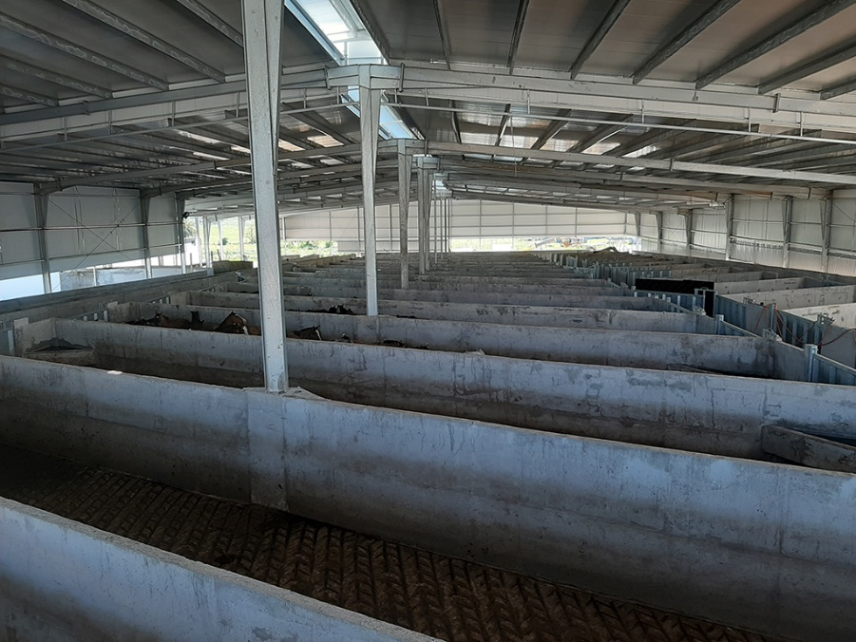
Figure 3: New, spacious covered waiting area with insulated roof at Clay.
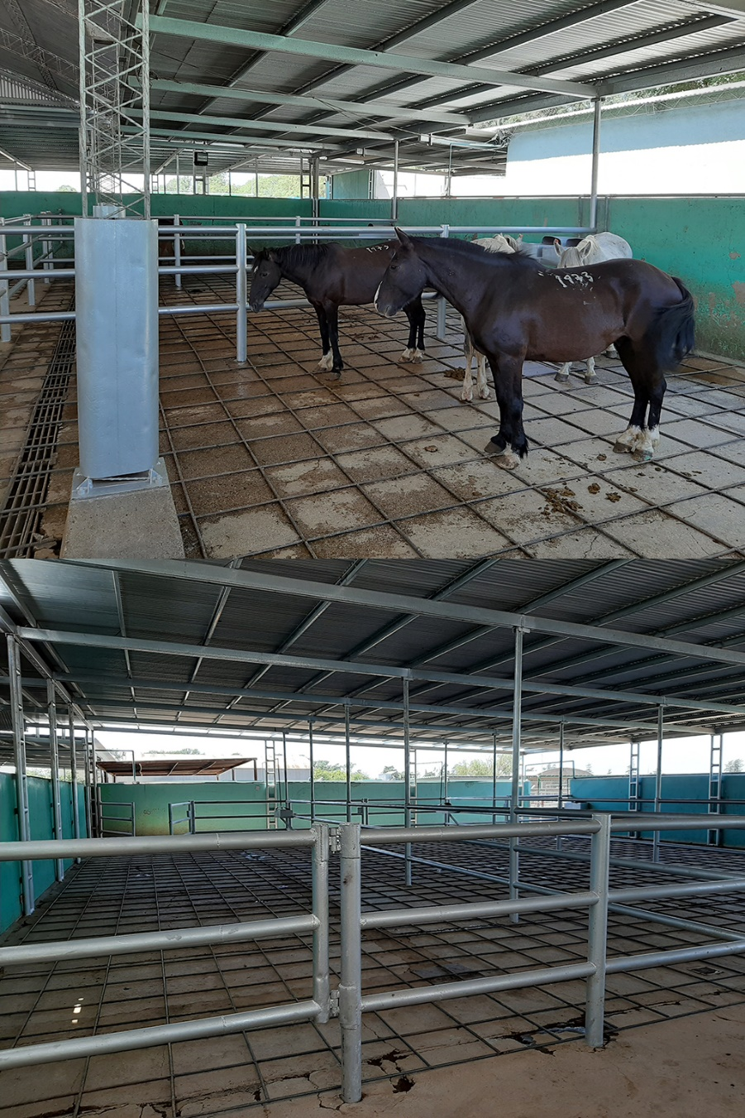
Figure 4: Covered waiting area for the horses at Land L.
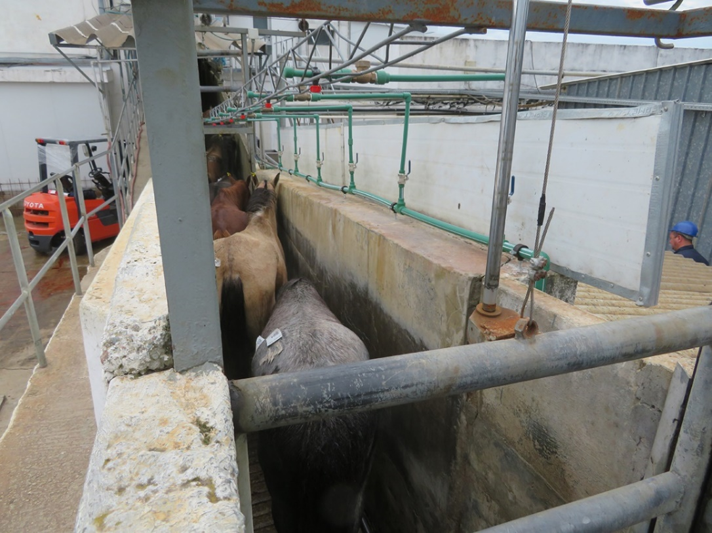
Figure 5: Shower that starts slowly with a fine spray, which is less stressful for the horses.
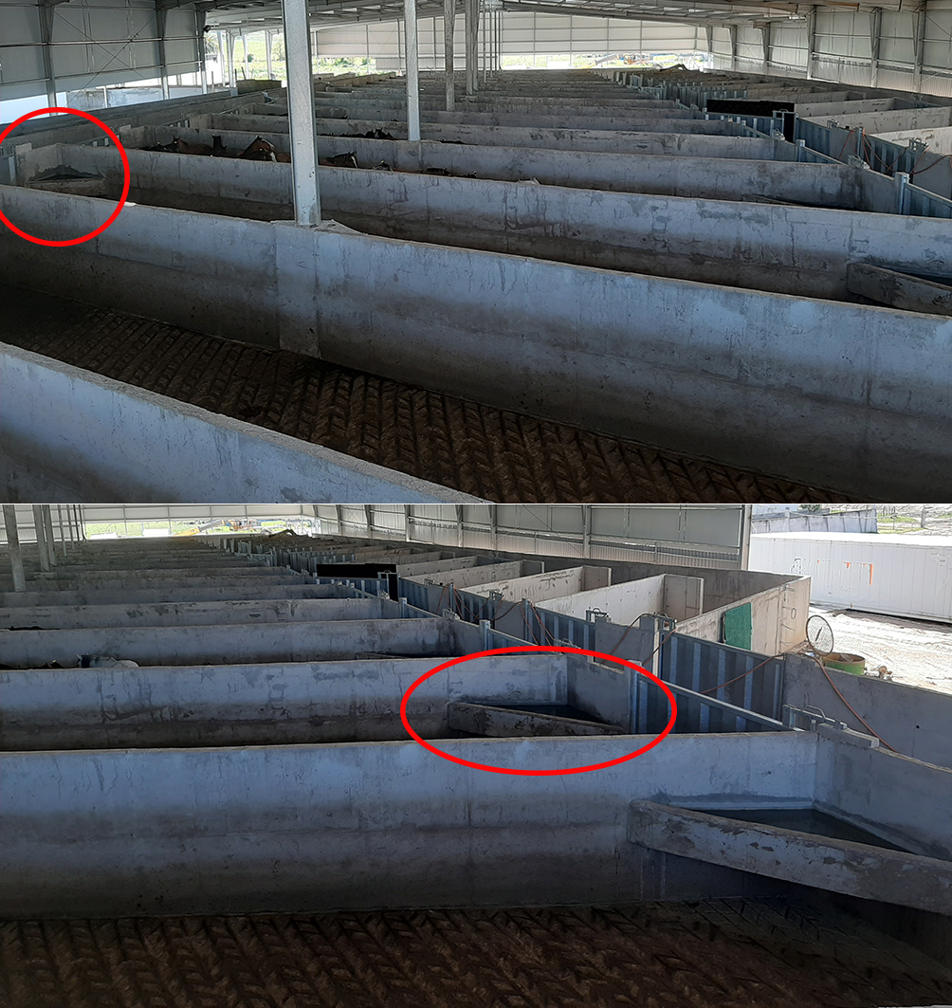
Figure 6: A fishbone-shaped waiting stall and high, equally close side walls in the driving passageways.
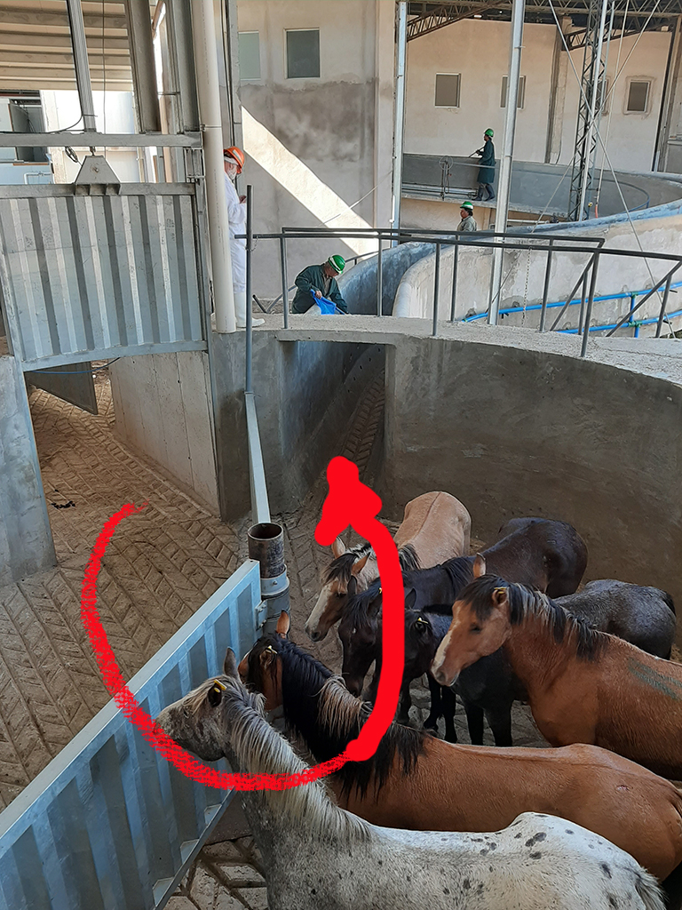
Figure 7: Carousel rather than a sharp turn in the driving section.
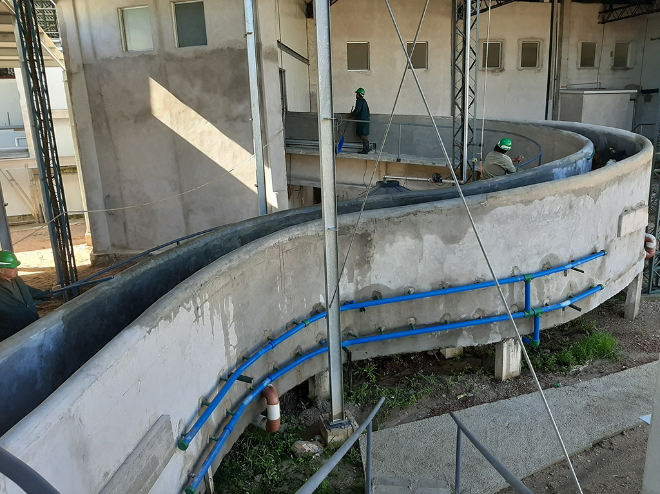
Figure 8: Slightly ascending S-shaped driving passage to the restraint box.

Animal & Welfare Research Group
email: bert.driessen@dierenwelzijn.eu
email: sanne.vanbeirendonck@dierenwelzijn.eu
email: jos.vanthielen@dierenwelzijn.eu
www.diereninformatie.be

