Animal & Welfare
Research Group

Horse collection centres, transport and slaughterhouses

Report on site visits to Shelby collection centre (USA) and transport to Fort Macleod slaughterhouse and feedlots for bison and horses (Canada)
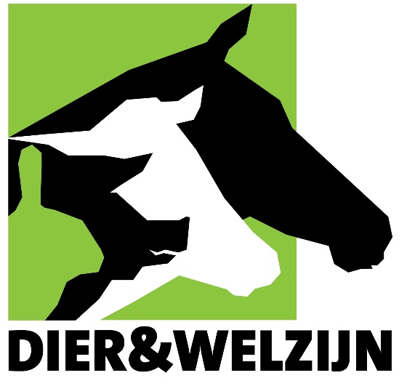

Bert Driessen
Jos Van Thielen

April 2019
Preface

This report reflects the overall impression (visual observations and measurements of environmental parameters) at the time of the follow-up company visits, which lasted a few hours per company. The situation (animals, staff and infrastructure) was studied at the time of the visit and the observations made were then tested against standards, norms, etc. relating to animal welfare. In addition, photographic and video material was gathered during the site visits in order to be analysed afterwards. During this seven-day tour of Canada, two slaughterhouses and three collection centres were visited.
The site visit was conducted by Bert Driessen and Jos Van Thielen of the Animal & Welfare research group, who have many years’ experience in the field of animal welfare and behaviour, and more specifically in relation to the monitoring of animals during their transport to and stay at slaughterhouses.

Programme
Monday, 8 April 2019
Visit to/audit of a feedlot in Shelby (USA)
Tuesday, 9 April 2019
Visit to feedlots near the slaughterhouse + visit to/audit of the slaughterhouse in Fort Macleod (Canada)
Thursday, 11 April 2019
Visit to the collection centre in Napanee + horse transport to Richelieu slaughterhouse (Canada)
Friday, 12 April 2019
Visit to/audit of the Richelieu slaughterhouse in Massueville (Canada)

Summary and conclusion
On Monday, 8 April 2019, a horse transport from the collection centre in Shelby (USA) to the slaughterhouse in Fort Macleod (Canada) was observed. The animals were monitored during loading in Shelby, during unloading and loading for individual inspection at the USA-Canada border and during unloading at the slaughterhouse in Fort Macleod.
On Tuesday, 9 April, we first made a visit to the feedlot for horses adjacent to the slaughterhouse site. Afterwards, we were able to observe and record how the horses are driven in the slaughterhouse as well as the shooting/stunning process. We then visited a large feedlot for bison and another feedlot for horses.
On Thursday, 11 April 2019, a horse transport from the collection centre in Napanee to the Richelieu slaughterhouse in Massueville was observed (approximately 470 km). The animals were observed as they were loaded in Napanee and unloaded at the Richelieu slaughterhouse.
On Friday, 12 April 2019, the process of slaughtering horses at the Richelieu slaughterhouse in Massueville was observed, from driving the horses from the stall to the shoot box up to and including the bleeding.
At each location visited, the company executives and staff collaborated fully and granted access to all their premises. At the request of the researchers, the horse driving, stunning and bleeding was examined in each case as far as possible, so as to be able to form a good overview of the expertise and infrastructure available. Each location was in operation at the time of the observation. All these locations were visited for the first time by the researchers.
Systematic testing of the infrastructure in place (based on the Five Freedoms) in terms of animal welfare was conducted. The facilities for loading the animals (at the collection points and the feedlots) and unloading them (in the slaughterhouses), the facilities for driving them to temporary waiting areas, the facilities for driving them to the stunning area and the facilities in this area were systematically inspected. The existing infrastructure was subjected to visual inspection so as to be able answer a number of questions. Is all the necessary infrastructure present to enable animal-friendly treatment of the horses? The staff were observed for several hours in order to assess their skills and expertise in handling horses (and bison) and to answer the following questions. Did the staff have sufficient skills to handle the animals in a speedy and animal-friendly manner? Is the staff able, sufficiently aware and experienced to accurately estimate potential problem situations and handle them correctly? During the site visits, objectively measurable and appropriate parameters regarding animal welfare such as light intensity, temperature, air flow, ambient noise, disturbing shafts of light and shadow spots were systematically recorded at various spots at the companies.
It was noted in both slaughterhouses that the animals were properly were driven to the restraint box, stunned and bled. Nevertheless, the researchers suggested points of improvement to promote the speed and ease of the work (e.g. driving the animals) and thus reduce stress among the horses.
Dry ground is essential for the animals (both horses and bison) in the feedlots and waiting areas from an animal welfare perspective. It is also desirable to install fencing such as windbreaks around the feedlots/waiting areas or to provide a shelter.
Disruptive noises must be avoided in the vicinity of the animals (e.g. the shoot box in the slaughterhouse, the treatment boxes in the feedlots, etc.). These noises excite the animals, making it more difficult to drive the horses or bison. A few adaptations to the infrastructure could also facilitate the work and improve comfort for the animals and staff.
It is also important that the right aids are used in the correct way when driving. Furthermore, it is essential that the animals do not receive conflicting signals from the drivers when driven or handled.
The discussions held indicate that those in charge are open to advice on possible points for improvement. The points for improvement/points for attention included in this report can, if followed up, improve animal welfare. In addition, adapting the points for improvement will make it easier to handle and drive the horses and bison. The points for improvement put forward will be examined and assessed at a subsequent visit.

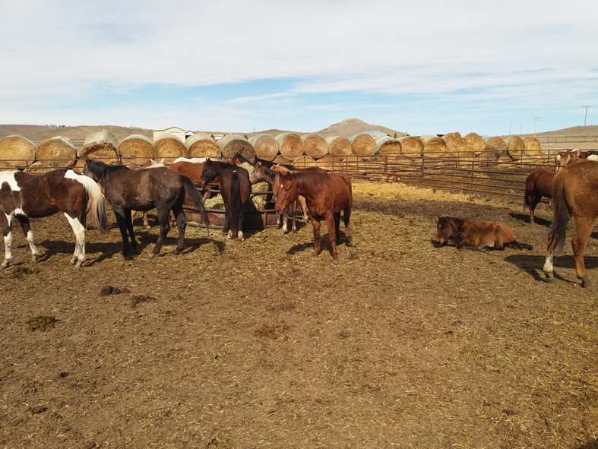
Figure 1: Round bales of straw serve as a windbreak screen.

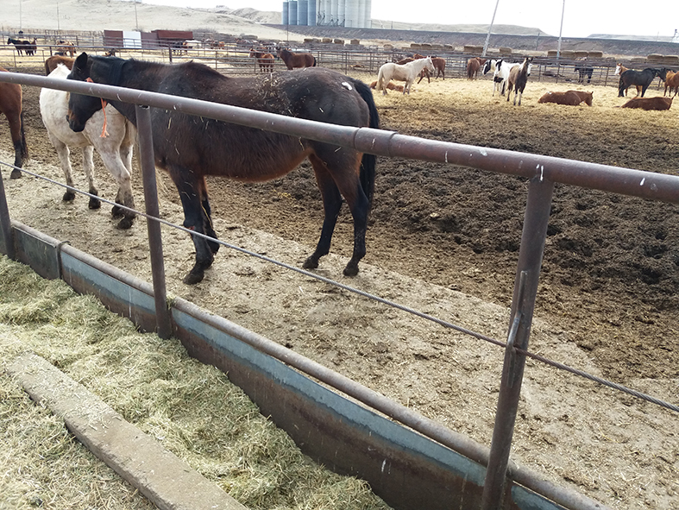
Figure 2: Hard flooring in front of the feeding trough.
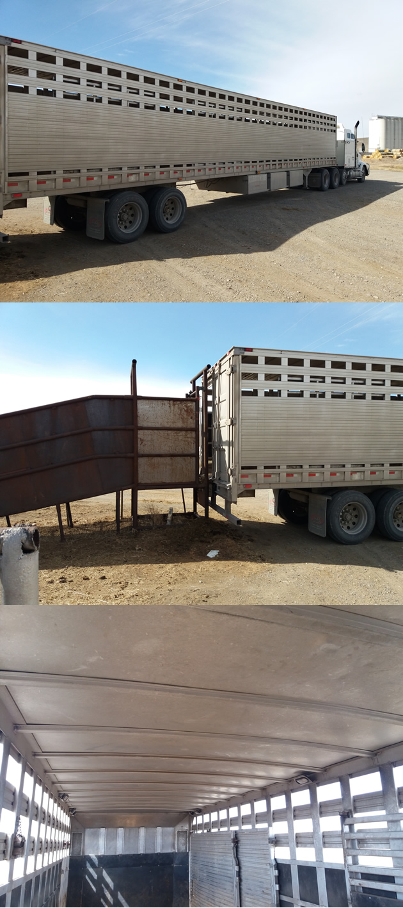
Figure 3: Trailer with openings for natural ventilation.

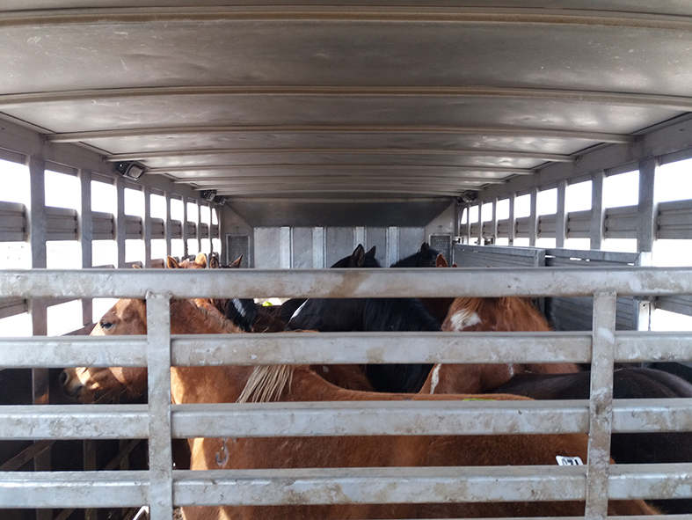
Figure 4: Horses have enough space above their heads.

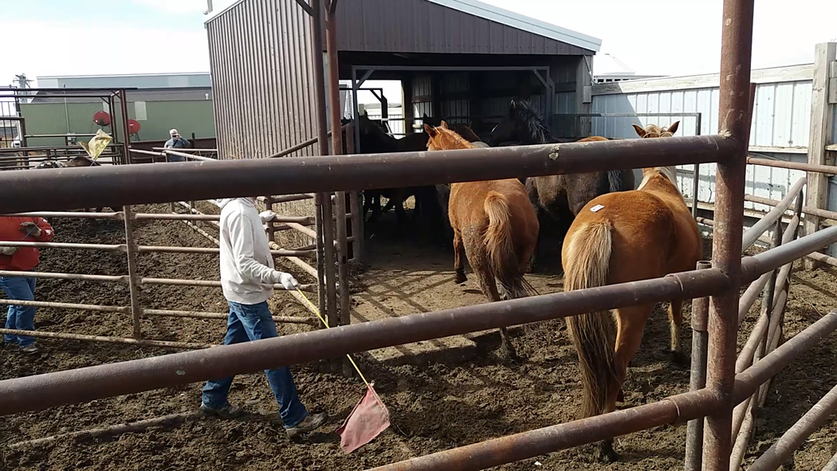
Figure 5: Driving to group scale takes place calmly, using a stick with a flag.

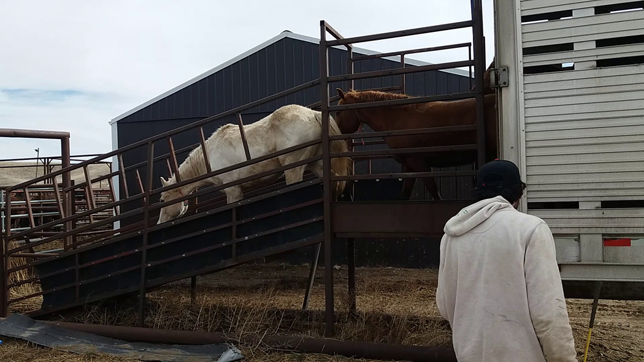
Figure 6: The horses are unloaded from the trailer calmly, as they are loaded.

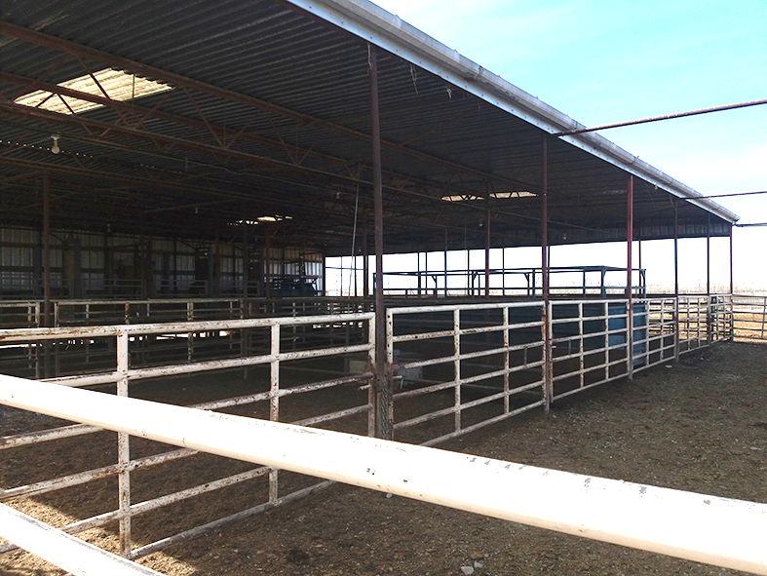
Figure 7: Covered waiting areas at the slaughterhouse.
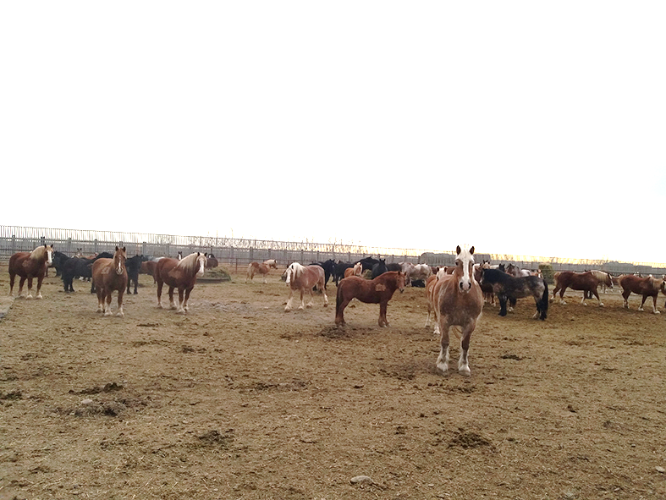
Figure 8: Dry ground in the feedlots at the slaughterhouse.

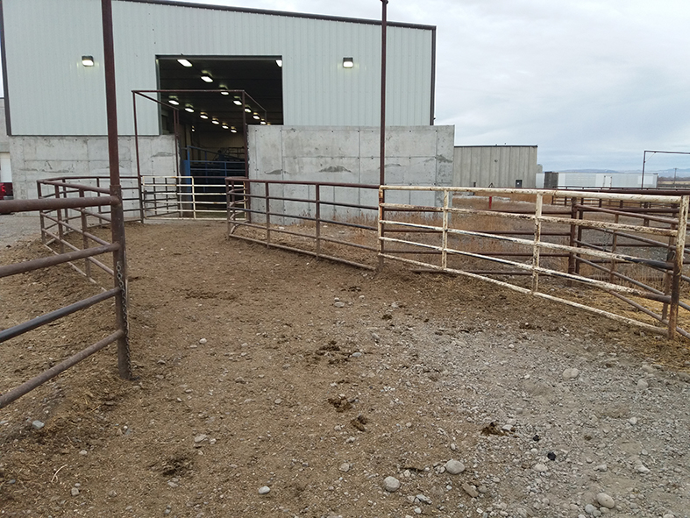
Figure 9: Driving corridor on the way to the waiting area at the slaughterhouse.
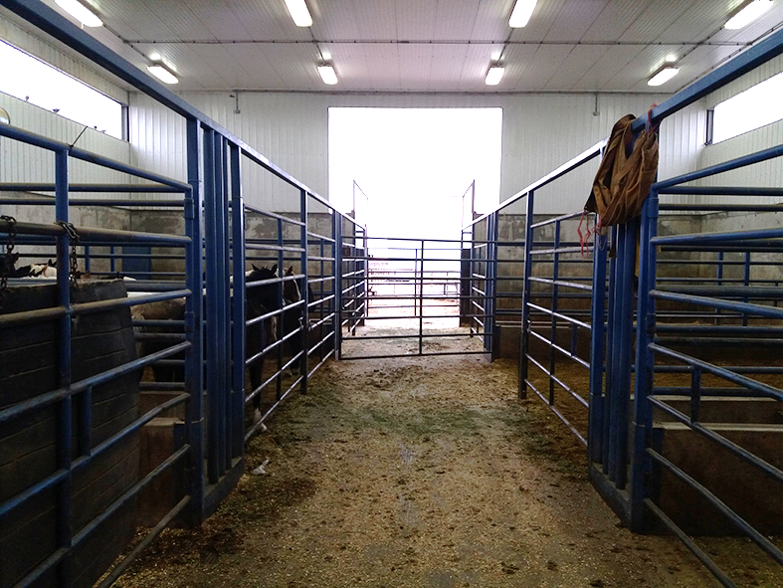
Figure 10: View of the holding pens inside the slaughterhouse.

Animal & Welfare Research Group
email: bert.driessen@dierenwelzijn.eu
email: jos.vanthielen@kuleuven.be
www.diereninformatie.be

